**Configure 80mm wifi Printer**

Platform - windows

**Printer Model - 80mm wifi printer(mj8330)**

**Steps**

1.Connect the Printer with USB(Video-01)

2.Do the IP configuration using wifi tool(WIFI OneKey Setting-80mm-mj8330.exe)/(Video-02)

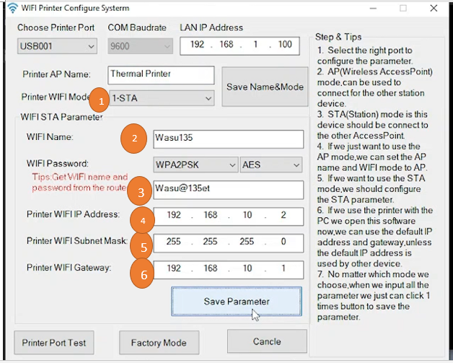

1. Printer WIFI Mode - **1-STA (After select this click “Save Name&Mode”)**
2. WIFI Name
3. WIFI Password
4. **Printer** WIFI IP Address
5. Subnet Mask
6. Printer WIFI Gateway(After enter these values click **“Save Parameter”**)

* ***Then Click “Printer Port Test”(Test Print).***
* ***Restart the Printer***
* ***Remove USB Cable and “ping”***

3. Create a New Printer PORT(Video-03)

4. Driver Install and Print test page using WIFI(Video-04,Video-05)

5. Select Printer from CloudPOS Windows App and do sales(Video-06,Video-07)

NOTE

If you need to remove added PORT

Click “Windows key+R”

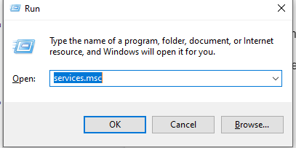

Run above command

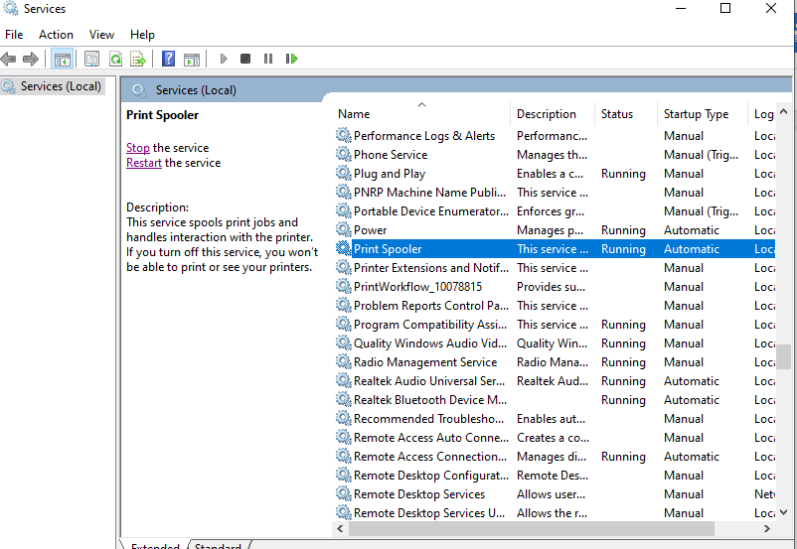

Select printer spooler from list.

Click Stop the service. Then remove added IP PORT